📊
STOCK ANALYZER PRO
Technical Documentation

Indian NSE / BSE Stock Analysis Platform
Version 2.0 | Python + Flask + Yahoo Finance

1. Project Overview
Stock Analyzer Pro is a full-stack web application for analyzing Indian stock market (NSE/BSE) equities using real-time data. It fetches live market data from Yahoo Finance and generates actionable BUY / SELL / HOLD signals based on a combination of technical, fundamental, and historical analysis.

The project consists of a Python backend (Flask REST API) built from six specialized modules, and a modern browser-based GUI served from the same server. No heavy frameworks are used — the entire stack relies on pure Python and standard web technologies.
1.1 Key Highlights
- Database of 500+ Indian stocks — Large Cap, Mid Cap, Small Cap, and a custom watchlist (DB_Stocks)
- Fully dynamic signal generation — no hardcoded rules; everything is formula-driven with continuous scoring
- Three-layer analysis in one view: Technical + Fundamental + Historical
- Built-in backtesting engine — generate signals for any past date and see real outcomes
- One-click export to Excel (.xlsx) and HTML / TXT / DOCX reports
- Clean REST API — frontend and backend are fully decoupled
- In-memory caching — avoids redundant Yahoo Finance API calls during a session

2. System Architecture
The project follows a layered architecture where each layer has a clearly defined responsibility:

Layer | Description
Presentation | Browser-based GUI (HTML / CSS / JS) — templates/index.html
API Gateway | Flask REST Server — app.py (port 8080)
Business Logic | Five core Python modules (signal_engine, comprehensive_analyzer, etc.)
Data Access | data_fetcher.py → Yahoo Finance via yfinance library
Data Storage | Excel file for stock database + in-memory session cache
2.1 Module Dependency Map
All modules are initialized once when the Flask server starts and shared across requests:

main.py / app.py (Flask entry point)
├── stock_loader.py ← Excel DB loader + smart search
├── data_fetcher.py ← Yahoo Finance API + cache
├── signal_engine.py ← Technical indicator scoring
├── comprehensive_analyzer.py ← Full analysis (Tech + Fund + Hist)
├── backtester.py ← Historical signal testing
├── excel_exporter.py ← Export session history to .xlsx
└── report_exporter.py ← Export reports to .txt / .html / .docx

Important: Every module is independent and can be imported and tested individually. All Python files and the Excel database must reside in the same directory.

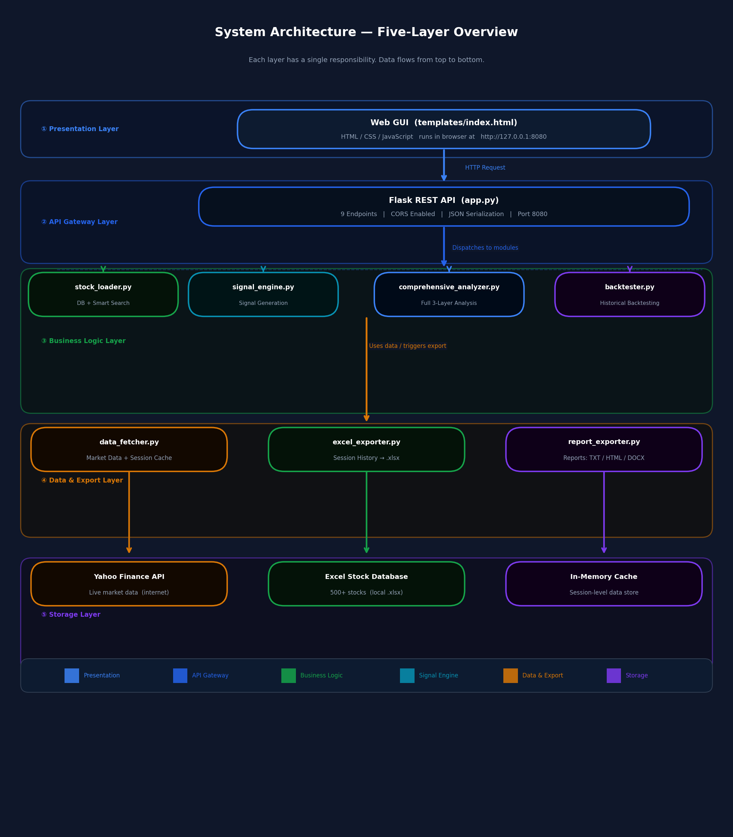
Figure 1 — System Architecture: Five-Layer Module Overview

3. Complete Workflow
The following sequence describes the full execution flow when a user analyzes a stock:

- User types a stock symbol or company name in the search bar
- Frontend sends GET /api/search?q=RELIANCE to the Flask server
- stock_loader.py performs a smart fuzzy search and returns up to 10 ranked matches
- User clicks a result — frontend sends GET /api/analyze/RELIANCE
- data_fetcher.py checks the in-memory cache; if not cached, fetches 2 years of OHLCV data from Yahoo Finance
- comprehensive_analyzer.py executes all three analysis layers: Technical, Fundamental, Historical
- signal_engine.py calculates weighted scores from 9 indicators and determines the final BUY / SELL / HOLD signal
- app.py serializes the result to JSON (handling all numpy/pandas types) and returns it
- The GUI renders the result in animated cards with color-coded signals, score cards, and trading plan

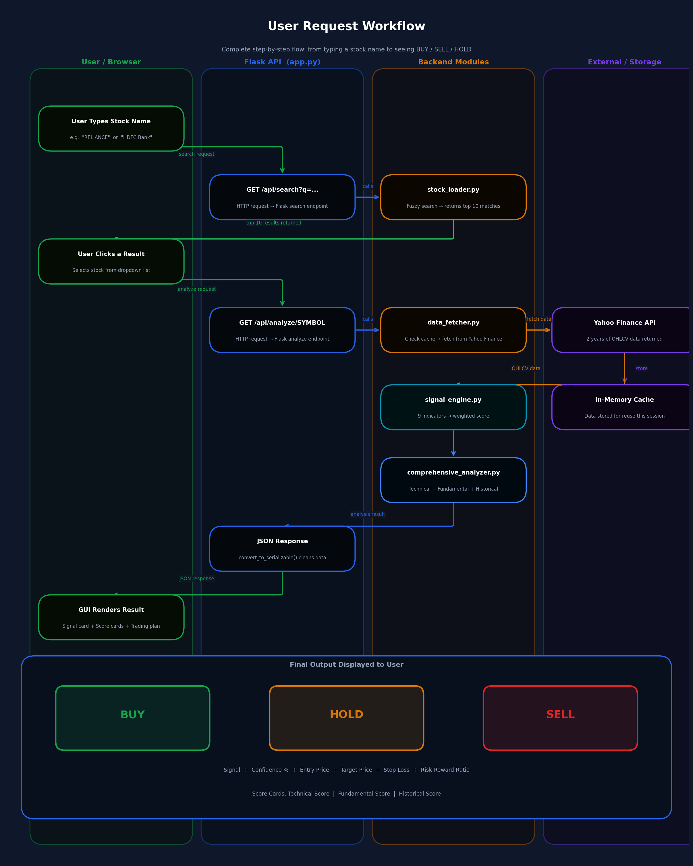
Figure 2 — User Request Workflow: End-to-End Flow from Search to Rendered Signal

3.1 Signal Generation Logic
The core principle of the signal engine is: no hardcoded thresholds. Each indicator produces a continuous score between −1 (strongly bearish) and +1 (strongly bullish). These are weighted and combined into a final score.

Indicator | Scoring Formula
RSI | Score = (50 − RSI) / 50 → Range: −1.0 to +1.0
MACD | Histogram normalized by its rolling standard deviation
MA Trend | Price vs SMA 20 / 50 / 200 each normalized by ATR, plus alignment bonus
Bollinger Bands | Position within bands using mean-reversion logic
Stochastic %K | (50 − K) / 50 weighted with K/D crossover direction
Volume | (Current Volume / 20-day Average Volume − 1) / 2
Momentum | 10-day price momentum normalized by its standard deviation
ATR Position | Distance from SMA-20 in ATR units (signals potential mean reversion)
ADX | DI+ minus DI− normalized, weighted by trend strength (ADX value)

Signal Decision Rules:

Condition | Result
Final Score > +0.2 | 🟢 BUY Signal
Final Score < −0.2 | 🔴 SELL Signal
Final Score between −0.2 and +0.2 | 🟡 HOLD Signal
Confidence % | abs(final_score) × 100, capped at 95%
Entry Price | Last closing price on the analysis date
Target Price | Entry + (1.5 × ATR) for BUY; Entry − (1.5 × ATR) for SELL
Stop Loss | Entry − (1.0 × ATR) for BUY; Entry + (1.0 × ATR) for SELL
3.2 Default Indicator Weights
Indicator | Default Weight
RSI | 15%
MACD | 15%
Moving Average Trend | 15%
Bollinger Bands | 10%
Stochastic Oscillator | 10%
Volume Analysis | 10%
Momentum | 10%
ATR Position | 5%
ADX (Trend Strength) | 10%

Configurable: Weights can be adjusted by editing the self.weights dictionary in signal_engine.py. All weights must sum to 1.0.

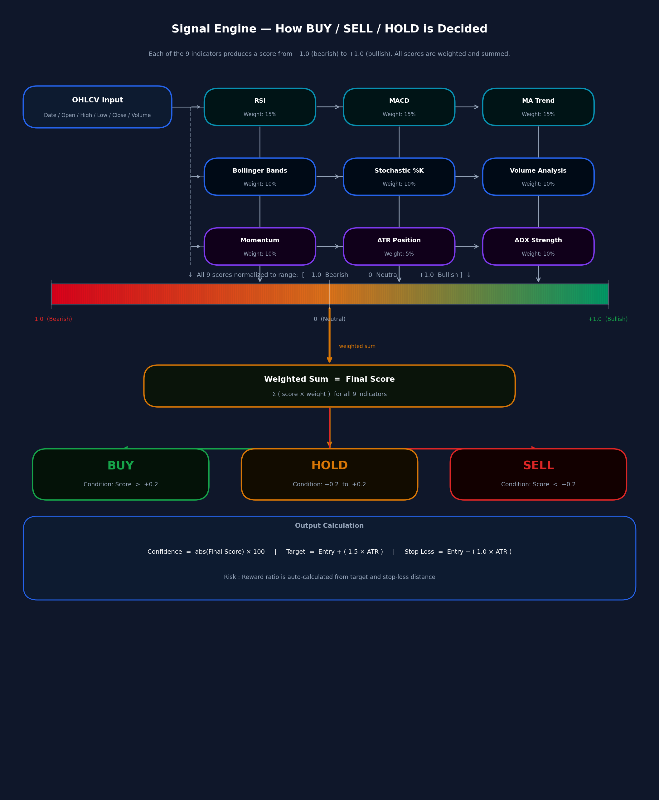
Figure 3 — Signal Engine: How Each Indicator Contributes to the Final BUY / SELL / HOLD Decision

4. Module-by-Module Reference
4.1 stock_loader.py — Stock Database & Search Engine
Loads the stock database from the Excel file and provides a multi-strategy smart search interface.

Class | StockLoader
Constructor | StockLoader("Indian_Stocks_Complete_Market_Cap_Classification.xlsx")
Sheets Loaded | DB_Stocks, Large Cap (100), Mid Cap (150), Small Cap (250)
Total Stocks | ~500+ entries
Primary Search Method | search_stock(query) → returns top 10 matches ranked by relevance score
Lookup Method | get_stock_info(symbol) → returns full stock metadata
Fuzzy Matching | Python difflib.SequenceMatcher — threshold: ratio > 0.5

Search priority order (highest score wins):
- Exact symbol match → Score 100
- Symbol starts with query → Score 90
- Symbol contains query → Score 80
- Exact company name match → Score 85
- Company name contains query → Score 70
- Fuzzy similarity match (ratio > 0.5) → Score up to 60
- +5 bonus applied to stocks in the DB_Stocks watchlist
4.2 data_fetcher.py — Market Data Retrieval
Fetches OHLCV (Open, High, Low, Close, Volume) historical data from Yahoo Finance. Implements in-memory caching to avoid duplicate API calls within the same session.

Class | DataFetcher
Primary Exchange | NSE — .NS suffix appended automatically
Fallback Exchange | BSE — .BO suffix used if NSE returns empty data
Default Period | 1 year (period="1y")
Analysis Period | 2 years (period="2y") used for comprehensive analysis
Cache Key Format | symbol_period_interval (e.g., RELIANCE.NS_2y_1d)
Columns Returned | Date, Open, High, Low, Close, Volume
Timezone Handling | Timezone info stripped from Date column automatically

Available methods:
- fetch_data(symbol, period, interval) — primary fetch method with cache check
- fetch_data_by_date_range(symbol, start_date, end_date) — custom date range fetch
- get_current_price(symbol) — returns the latest available closing price
- get_stock_info(symbol) — returns company name, sector, 52-week range, market cap
- clear_cache() — flushes the in-memory cache dictionary

Configurable: The period parameter in fetch_data() accepts: "1mo", "3mo", "6mo", "1y", "2y", "5y". The interval parameter accepts: "1d" (daily), "1wk" (weekly), "1mo" (monthly).
4.3 signal_engine.py — Technical Signal Generator
The core technical analysis engine. Calculates all 9 indicators, converts them to normalized scores, applies weights, and produces the final trading signal with entry, target, and stop-loss levels.

Class | SignalEngine
Input | Pandas DataFrame with Date / Open / High / Low / Close / Volume columns
Output | Dictionary: signal, confidence, entry_price, target_price, stop_loss, scores, indicators
Minimum Data Required | 50 rows (trading days)
Optional Analysis Date | Defaults to latest date; any past date can be specified for backtesting
Indicator Calculations | All indicators computed inline using pandas/numpy — no external TA library

Indicators calculated:
- RSI (Relative Strength Index) — 14-period, using Wilder smoothing
- MACD — EMA(12) − EMA(26) with signal line EMA(9) and histogram
- Simple Moving Averages — SMA 20, SMA 50, SMA 200
- Exponential Moving Average — EMA for trend confirmation
- Bollinger Bands — 20-period SMA ± 2 standard deviations
- Stochastic Oscillator — %K(14) and %D(3)
- ATR (Average True Range) — 14-period, True Range max of three components
- ADX with +DI and −DI — 14-period Average Directional Index
- Momentum — 10-period percentage change
4.4 comprehensive_analyzer.py — Full Three-Layer Analysis
Combines technical, fundamental, and historical analysis into a single comprehensive report with an overall score and detailed trading plan.

Class | ComprehensiveAnalyzer
Technical Score | 0 – 100, derived from weighted indicator scores (same logic as SignalEngine)
Fundamental Score | 0 – 100, based on PE, PB, ROE, Debt/Equity, and dividend yield
Historical Score | 0 – 100, based on 52-week position, recent returns, support/resistance levels
Overall Score | Weighted average: 40% Technical + 30% Fundamental + 30% Historical (default)
Fundamental Data Source | Yahoo Finance ticker.info API — fetched live for each analysis
Market Cap Format | Auto-formatted to Cr / K Cr / Lakh Cr for readability

Fundamental scoring criteria:
Metric | Score Adjustment Logic
PE Ratio | Below 15 (+10 pts) | Below 25 (+5) | Below 40 (−5) | Above 40 (−10)
PB Ratio | Below 1.0 (+10 pts) | Below 3 (+5) | Below 5 (−5) | Above 5 (−10)
Return on Equity | Above 20% (+10) | Above 15% (+5) | Above 10% (0) | Below 10% (−5)
Debt / Equity | Below 50% (+10) | Below 100% (+5) | Below 150% (−5) | Above 150% (−10)
Dividend Yield | Above 3% (+5 pts) | Above 1% (+2 pts)
4.5 backtester.py — Historical Signal Testing
Generates signals for any specified past date using the same SignalEngine logic, then analyzes what actually happened to the stock after that date.

Class | Backtester
Internal Dependency | Uses SignalEngine internally
Outcome Measurement Periods | 1 Day | 7 Days (≈5 trading days) | 30 Days (≈20 trading days)
Accuracy Definition | 7-day price direction vs signal direction (CORRECT / INCORRECT / NEUTRAL)
Target / Stop Check | Scans each future row to determine which was hit first — target or stop loss
Range Backtest Method | backtest_range(df, start, end, symbol, interval_days)
Summary Statistics | get_summary_stats() → accuracy %, average 7-day P&L, signal counts
Results Storage | All results stored in self.results list; cleared with clear_results()

Accuracy rule: A BUY signal is marked CORRECT if the closing price after 7 trading days is higher than the entry price. A SELL signal is CORRECT if the price is lower. Zero change = NEUTRAL.
4.6 excel_exporter.py — Excel Export
Accumulates all live signals, backtest results, and search queries during a session and exports them to a formatted multi-sheet Excel workbook.

Class | ExcelExporter
Library | openpyxl via pandas ExcelWriter
Sheet 1 — Live_Signals | All live analysis results with full indicator values
Sheet 2 — Backtest_Results | All backtest results with outcomes at 1D / 7D / 30D intervals
Sheet 3 — Search_History | Timestamped log of all user search queries
Sheet 4 — Performance_Summary | Aggregated stats: accuracy %, average P&L, signal counts
Auto-Open | Windows: os.startfile() | macOS: open | Linux: xdg-open
Default Filename | Stock_Analysis_History_YYYYMMDD_HHMMSS.xlsx
4.7 report_exporter.py — Individual Report Export
Saves a complete analysis report for a single stock in up to three formats simultaneously.

Class | ReportExporter
TXT Format | Plain text file readable in any editor — always available
HTML Format | Styled browser report with color-coded sections and a print button — always available
DOCX Format | Word document with formatting (requires python-docx library to be installed)
Reports Folder | analysis_reports/ directory created automatically in the project folder
Default Filename Pattern | SYMBOL_Analysis_YYYYMMDD_HHMMSS.{ext}

5. Flask REST API Reference
app.py runs the Flask server on port 8080 and exposes the following endpoints. All responses follow a consistent JSON envelope format.

Endpoint | Method | Description
GET / | GET | Serves the main web GUI (templates/index.html)
GET /api/stats | GET | Returns stock database counts per category
GET /api/search?q=QUERY | GET | Smart stock search by symbol or company name
GET /api/analyze/SYMBOL | GET | Full comprehensive analysis using 2 years of data
GET /api/quick-signal/SYMBOL | GET | Signal engine output only using 1 year of data
GET /api/backtest/SYMBOL?date=YYYY-MM-DD | GET | Single-date backtest with outcome analysis
GET /api/current-price/SYMBOL | GET | Returns the latest available market price
GET /api/stock-info/SYMBOL | GET | Company metadata: name, sector, 52-week range, market cap
GET /api/category/CATEGORY | GET | All stocks in a category: large_cap, mid_cap, small_cap, db_stocks
5.1 Response Format
All endpoints return a standard JSON envelope:

// Success
{ "success": true, "data": { ... } }

// Failure
{ "success": false, "error": "Descriptive error message" }

CORS is enabled via flask-cors — any frontend origin can call the API. The convert_to_serializable() helper automatically handles numpy integers, numpy floats, NaN/Inf values, pandas Timestamps, Series, and DataFrames before JSON serialization.

6. Project File Structure
File / Folder | Purpose
main.py | Application entry point — starts Flask server and auto-opens browser
app.py | Flask application with all REST API route definitions
stock_loader.py | Excel database loader and smart search engine
data_fetcher.py | Yahoo Finance data retrieval with in-memory caching
signal_engine.py | Technical indicator calculations and signal generation
comprehensive_analyzer.py | Three-layer analysis: Technical + Fundamental + Historical
backtester.py | Historical signal backtesting and outcome evaluation
excel_exporter.py | Exports session history to multi-sheet .xlsx workbook
report_exporter.py | Exports individual stock reports to .txt / .html / .docx
Indian_Stocks_Complete_Market_Cap_Classification.xlsx | Stock database — 500+ stocks across 4 sheets
requirements.txt | Python package dependencies
templates/index.html | Web GUI frontend — auto-served by Flask at GET /
analysis_reports/ | Auto-created folder for saved stock report files

7. Setup & Installation
7.1 Prerequisites
- Python 3.7 or higher
- pip (Python package manager)
- Active internet connection (required for Yahoo Finance data)
- The Excel stock database file must be present in the project directory
7.2 Installation Steps
- Navigate to the project folder: cd stock_analyzer
- Create a virtual environment (recommended): python -m venv venv
- Activate on Windows: venv\Scripts\activate
- Activate on macOS / Linux: source venv/bin/activate
- Install all dependencies: pip install -r requirements.txt
- Start the server: python main.py
- The browser will open automatically at: http://127.0.0.1:8080
7.3 Python Dependencies
Package | Purpose
pandas >= 1.5.0 | DataFrame operations and data manipulation
numpy >= 1.21.0 | Numerical calculations for all technical indicators
yfinance >= 0.2.0 | Fetching market data from Yahoo Finance
openpyxl >= 3.0.0 | Reading the stock database Excel file and writing exports
flask >= 2.0.0 | Web server and REST API routing
flask-cors >= 3.0.0 | Enables cross-origin requests from the frontend
python-docx (optional) | Required only for .docx report export functionality

8. Configuration Guide
This section covers everything that can be customized without breaking the core application logic.
8.1 Indicator Weights
File: signal_engine.py → self.weights dictionary inside __init__

self.weights = {
'rsi': 0.15, # Increase to give RSI more influence
'macd': 0.15, # Adjust MACD weight
'ma_trend': 0.15, # Moving average trend weight
'bollinger': 0.10,
'stochastic': 0.10,
'volume': 0.10,
'momentum': 0.10,
'atr_position':0.05,
'adx': 0.10,
}

Constraint: All weight values must sum to exactly 1.0
8.2 Data Fetch Period
File: app.py → analyze_stock() function

df = data_fetcher.fetch_data(symbol, period='2y')
# Options: '1mo', '3mo', '6mo', '1y', '2y', '5y'
8.3 Signal Sensitivity Thresholds
File: signal_engine.py → analyze() method. Adjust to make the engine more or less sensitive:

if final_score > 0.2: signal = 'BUY' # Lower to 0.1 for more BUY signals
elif final_score < -0.2: signal = 'SELL' # Raise to 0.3 to require stronger confirmation
8.4 Target & Stop Loss Multipliers
File: signal_engine.py → analyze() method

target = entry_price + (1.5 * atr) # Increase for wider targets
stop_loss = entry_price - (1.0 * atr) # Increase for wider stop losses
8.5 Server Port
File: main.py → app.run() call

app.run(host='0.0.0.0', port=8080, debug=False, threaded=True)
# Change port=8080 to any available port number
8.6 Stock Database
- Add preferred watchlist symbols to the DB_Stocks sheet in the Excel file
- Add new entries to Large Cap / Mid Cap / Small Cap sheets as needed (columns: Symbol, Name, Sector/Industry, Market Cap)
- The Excel file must remain in the same directory as the Python files
8.7 Fundamental Scoring Bands
File: comprehensive_analyzer.py → calculate_fundamental_score() method. The PE, PB, ROE, and Debt/Equity scoring thresholds can be adjusted here to match sector-specific valuation norms.

9. Troubleshooting
Problem | Solution
"Module not found" error on startup | Run: pip install -r requirements.txt inside the activated virtual environment
Excel file not found error | Ensure Indian_Stocks_Complete_Market_Cap_Classification.xlsx is in the same folder as all .py files
Port 8080 already in use | Edit main.py and change the port number in app.run() to an available port (e.g., 8081)
No data returned for a stock | Verify the NSE symbol is correct. The app automatically appends .NS and falls back to .BO if needed
First analysis is slow | Normal behavior — Yahoo Finance is downloading historical data. Subsequent analyses for the same stock use the cache
Fundamental data shows N/A | Some stocks have incomplete data on Yahoo Finance. Technical analysis still runs; fundamentals show N/A
Excel file does not open automatically | The auto-open feature requires OS-level file association. Open the file manually from the output path shown in the terminal
Backtest returns "no future data" error | The backtest date is too recent. Choose a date at least 30 trading days before today to get complete outcome data
NaN or serialization error in API response | The convert_to_serializable() helper in app.py handles this — check that it is not being bypassed in custom endpoints

10. Quick Reference Card
Task | How To
Start the application | python main.py → opens http://127.0.0.1:8080 automatically
Search for a stock | Type symbol or company name in the search bar (fuzzy matching supported)
Run a full analysis | Click any search result — calls GET /api/analyze/SYMBOL
Get a quick signal only | GET /api/quick-signal/SYMBOL (faster, 1-year data)
Run a backtest | GET /api/backtest/SYMBOL?date=YYYY-MM-DD
Export session to Excel | Call exporter.export_to_excel() — auto-opens on Windows
Save an HTML report | report_exporter.save_report(symbol, text, "html")
Clear the data cache | data_fetcher.clear_cache()
Adjust indicator weights | Edit self.weights in signal_engine.py (must sum to 1.0)
Add stocks to watchlist | Add symbols to the DB_Stocks sheet in the Excel file
Change the server port | Edit port= in app.run() inside main.py
Get all large-cap stocks | GET /api/category/large_cap

DISCLAIMER
This tool is intended for educational and research purposes only.
Trading in financial markets involves substantial risk of loss. Always conduct your own research and consult a qualified financial advisor before making investment decisions.

